Containers are ephemeral in nature. They have short life and die and revive at any time

Problem1:

As there is only a single host like vm or physical server (The host on which you install Docker is called a ****Docker host****. It can be any machine that runs the Docker daemon, which is responsible for managing Docker containers. This host can be a physical server, a virtual machine, or even a cloud instance. If you have any more questions about Docker or its architecture, feel free to ask!)in Containers and if a container is slow or lack resources then the other containers get affected like not getting created or dying abruptly.

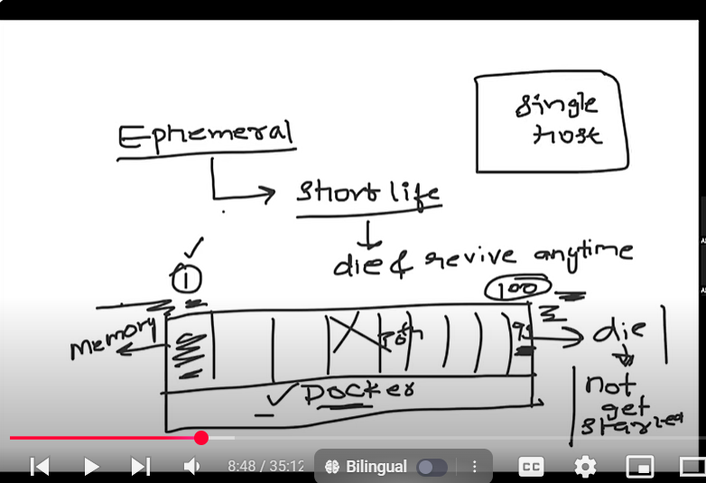

Problem 2:

If any container gets killed, the application inside it is not accesible.

Auto healing: Without any external intervention the container should start itself. But in Docker it is not possible.

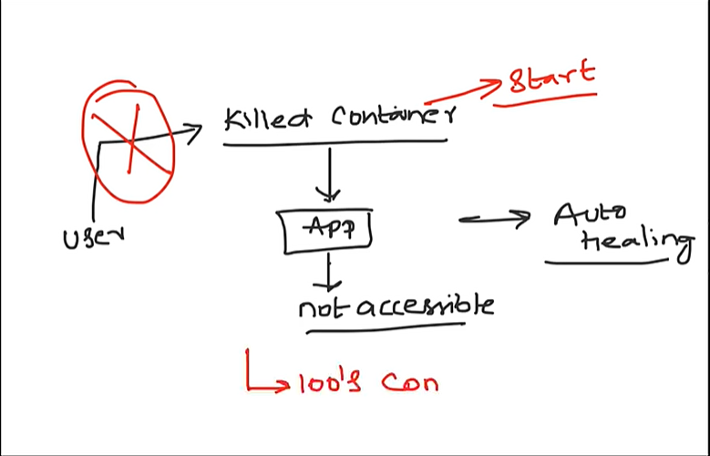

Problem 3:

Auto Scaling:

If in any case load increases, docker doesn’t scale up automatically. Load balancing is missing.

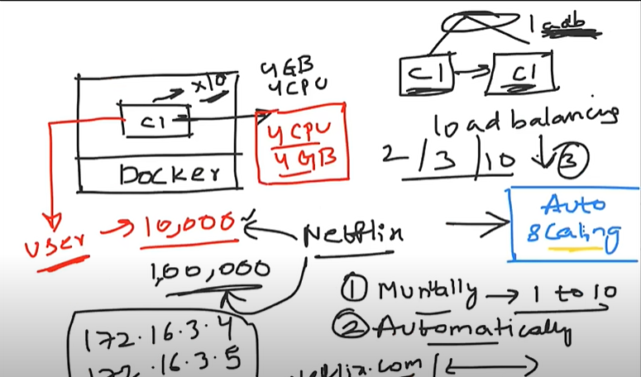

Problem4:

Docker doesn’t provide Enterprise level support like load balancer, Firewall, Autoscale, Healing, API Gateway etc.

So Docker is never used in Production. Docker swarm may be used in production.

KUBERNETES is the solution for the above problems.

KUBERNETES is a cluster which means group of nodes

And kubernetes is installed on master node.

Because of container1 if container10 is getting affetcted kubernetes puts container 10 in another node.

Replica sets- we can change load in YAML file

Kubernetes controls and fixes the damage. Whenever a container goes down a new container is created automatically and rolls out the damaged one

Kubernetes Architecture(K8s):

Docker--container Kubernetes--Pod

**The pod gets deployed onto the worker nodeby going through master node**

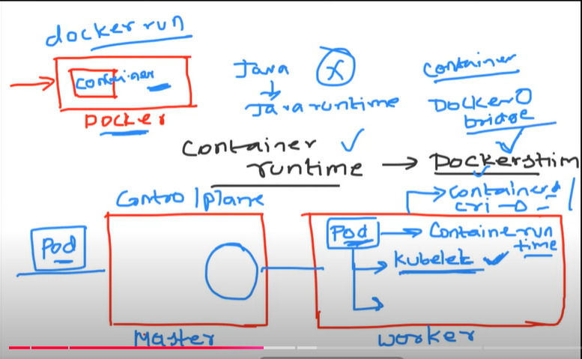

To run a docker container underlying container runtime like Dockershim is present.

In Kuberentes kublet is present to run a pod and responsible for Auto healing. Also docker container runtime is also present.

In production there will be multiple masters and workers.

Like bridge network in Docker kube-proxy in kubernetes.

Worker(Data Plane):

**Kublet**-- responsible for creation of pod and ensure pod is running properly

**Kube-proxy** -- responsible for generating networking concepts like ip addresses, loadbalancing and generally uses linux IP tables on Linux machines.

**Container runtime --** responsible for running a container

Master (Control plane)-

**APIserver --** exposes the kubernetes to the external world

 kubernetes API server which basically takes all the requests from external world

**Scheduler--** By getting instructions from API server decideswhich pod should get scheduled on which node

**Etcd**--cluster related info pesent in key value pair.

**Replica sets--** some controllers okay for example replica set so replica set is basically is the one that is maintaining state of your kubernetes

**Controller Manager**--one of my pod to two parts so there has to be a component in kubernetes that ensures that the two components or two pods are actually running so that is taken care by replica set in kubernetes ml file if you say I require two parts so a replica set controller basically ensures that the two pods are always running now there has to be a component in kubernetes which ensures such controllers are always running so that component is called as controller manager

Etcd

API server ----components of Master

Scheduler

Controller Manager

Cloud control Manager(C-C-M)

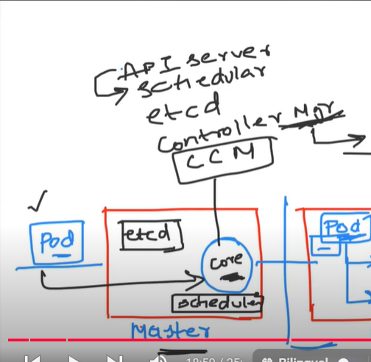

K8s Production Systems:

We should never use kubernetes minikube as it is development friendly and not production friendly.

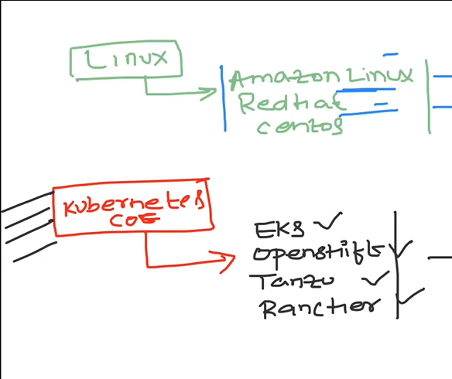

Distribution systems of Kubernetes EKS,Openshift etc

KOPS and KubeADM are used to maintain 100’s of clusters at a single time.

Creating Kubernetes cluster:

### Create S3 bucket for storing the KOPS objects.

$ aws s3api create-bucket --bucket kops-ganesh-storage --region us-east-1

### Create the cluster

$ kops create cluster --name=demok8scluster.k8s.local --state=s3://kops-ganesh-storage --zones=us-east-1a --node-count=1 --node-size=t2.micro --master-size=t2.micro --master-volume-size=8 --node-volume-size=8

In name we are using k8s.local for practice but in production it is used with domain name like k8.flipkart.com

How to configure cluster into Route53?

aws route53 create-hosted-zone --name dev.<domainname(flipkart.com)> --caller-reference1

Why an app is deployed in container in docker whereas in Kubernetes it is deployed in Pod instead of container?

Pod is a single or group of containers. Uses of putting multiple containers in a pod

* ****Pods****: In Kubernetes, a Pod is the smallest deployable unit. A Pod can encapsulate one or more containers that need to work together. The key reasons for using Pods instead of just containers include:
  + ****Shared Networking****: All containers in a Pod share the same IP address and network namespace, which makes it easier for them to communicate with each other.
  + ****Storage Sharing****: Pods can also share storage volumes, allowing multiple containers to share data efficiently.
  + ****Lifecycle Management****: Kubernetes manages the lifecycle of Pods, ensuring that containers within them are healthy and scaling them as needed.

Also as in docker we no need to run commands like docker run, instead we put them in YAML file.

If A and B are two containers in a pod then kubernetes allows them to communicate through localhost.

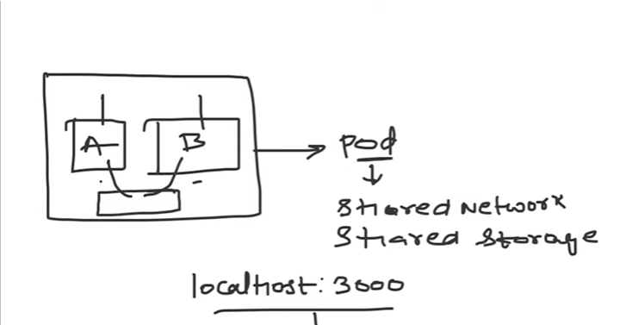

The cluster IP is allocated to a pod and all the containers inside it can be accessed by Pod IP address.

Kubeproxy generates the IP address.

Kubectl is like command line for kubernetes

**Steps to start kubernetes pod:**

Minikube start --memory=4096 --driver=hyperkit

$ kubectl get nodes

$kubectl create -f pod.yml

$kubectl get pods

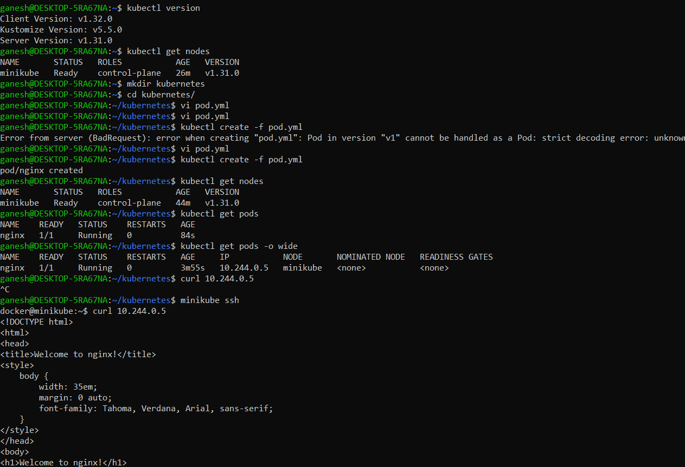

ganesh@DESKTOP-5RA67NA:~/kubernetes$ kubectl get pods -o wide

NAME READY STATUS RESTARTS AGE IP NODE NOMINATED NODE READINESS GATES

nginx 1/1 Running 0 3m55s 10.244.0.5 minikube <none> <none>

Login to the pod

Minikube ssh

Curl 10.244.0.5

->Kubectl logs pod <podname>

-----commands to debug pod

->kubectl describe pod <podname>

Deployment creates Replicasets which has auto scaling and auto healing properties will create a pod

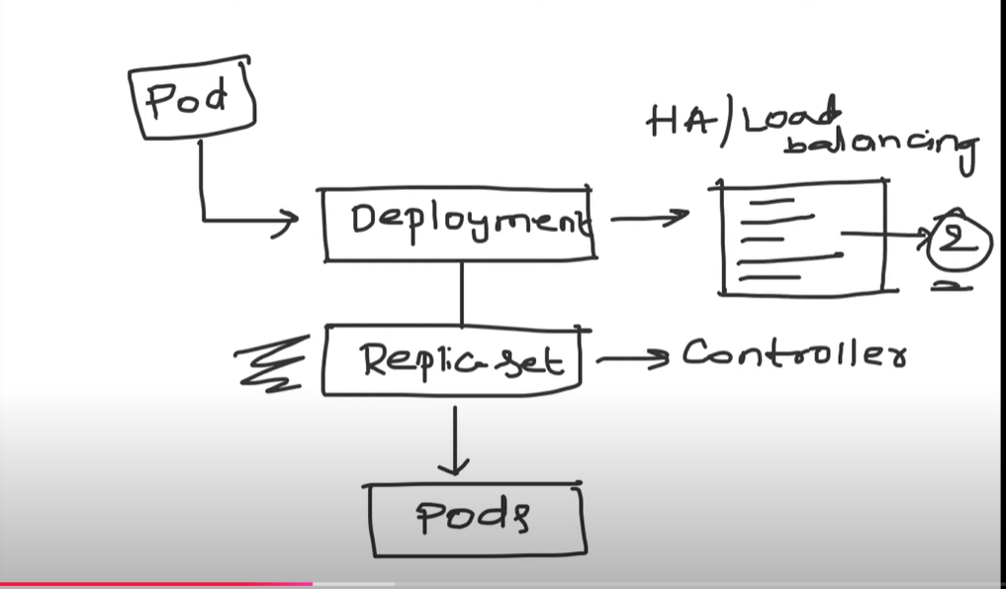

Pods should always be operated as deployment as autohealing and autoscaling features are present.

Replicasets is a controller in deployment which actually creates pod with autohealing and autoscalinglike properties.

### **Pod**

* ****Definition****: A Pod is the smallest, most basic deployable object in Kubernetes. It represents a single instance of a running process in your cluster.
* ****Components****: A Pod can contain one or multiple containers (usually related) that share the same network namespace and storage volumes.
* ****Lifecycle****: Pods are transient; they can be created and destroyed based on the needs of your applications.

### **Deployment**

* ****Definition****: A Deployment is a higher-level abstraction in Kubernetes that manages a set of identical Pods. It provides declarative updates to those Pods and ensures that the specified number of Pods are running at any given time.
* ****Features****: Deployments allow for features like rolling updates, rollback capabilities, and scaling up or down the number of Pods based on demand.
* ****Lifecycle Management****: It manages the Pods it creates, automatically replacing any Pods that fail or are terminated.

### **Key Differences**

* ****Purpose****: Pods are the basic unit of execution, whereas Deployments manage Pods for maintaining application availability and updates.
* ****Management****: Deployments provide mechanisms for replicating Pods, updating them, and managing their lifecycle, while Pods alone do not have these features.
* ****Scaling****: Deployments allow easy scaling of Pods, while individual Pods do not have built-in mechanisms for scaling.

In summary, while a Pod is a single unit of execution, a Deployment manages multiple Pods and provides additional functionalities for maintaining and updating those Pods over time. If you need more details or examples, feel free to ask!

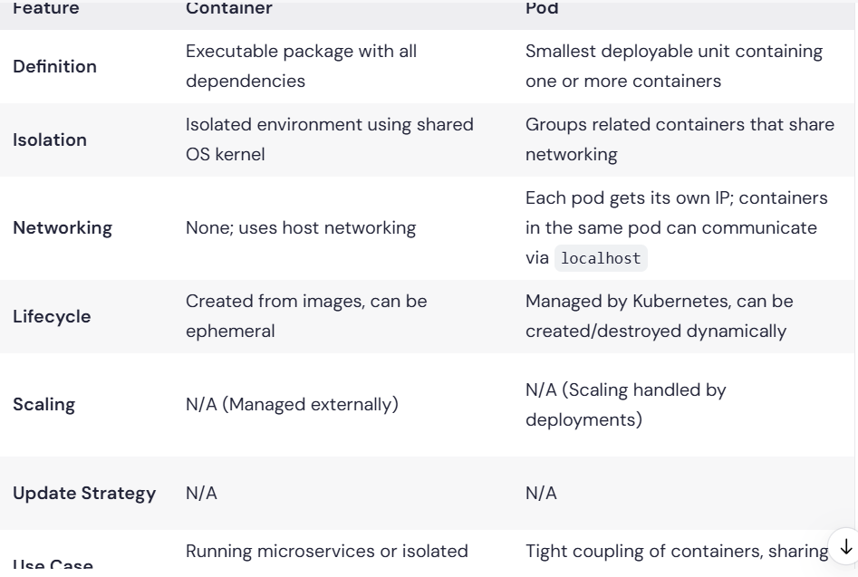

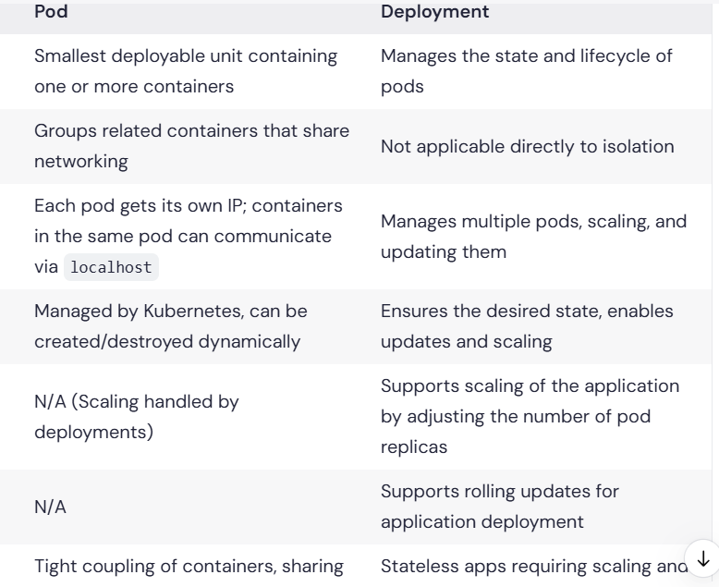

**kubectl get all --all-namespaces -o wide** (to get all the appliactions inside a cluster)

The command kubectl apply -f is used in Kubernetes to apply a configuration file to a resource, such as deployments, services, or any other defined Kubernetes object. The -f flag specifies the file or directory containing the configuration.

**kubectl apply -f <filename.yaml>**

**apiVersion: apps/v1**

**kind: Deployment**

**metadata:**

**name: nginx-deployment**

**labels:**

**app: nginx**

**spec:**

**replicas: 3**

**selector:**

**matchLabels:**

**app: nginx**

**template:**

**metadata:**

**labels:**

**app: nginx**

**spec:**

**containers:**

**- name: nginx**

**image: nginx:1.14.2**

**ports:**

**- containerPort: 80**

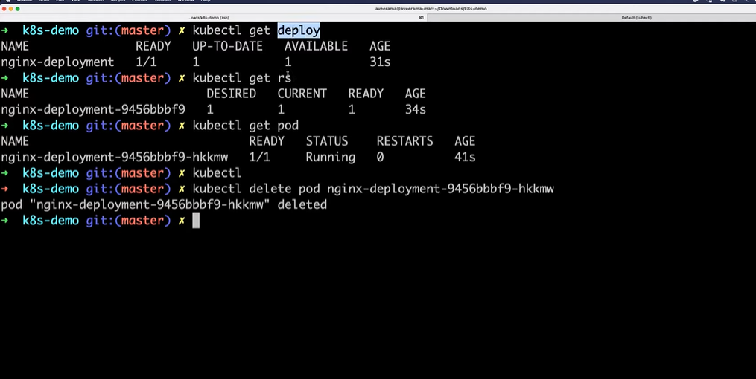

If we try to delete any pod then automatically another pod is created as the pod got created from deployment.

Kubectl get rs --- To get all the replicasets

Kubectl get pods -w -- To watch the backgroud process of what is happening.

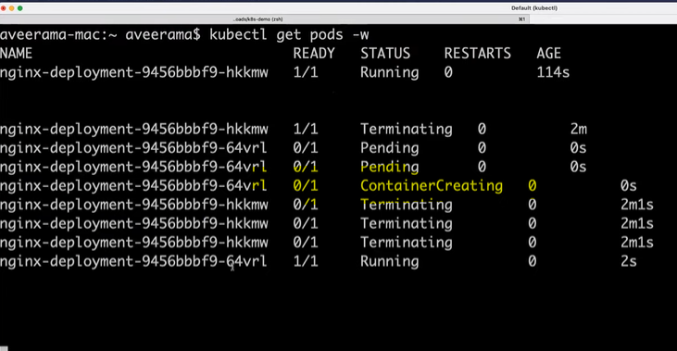

Service in Kubernetes:

Whenever we create a deployment, then we also create service.

Pod size depends on the number of concurrent users at the same time.

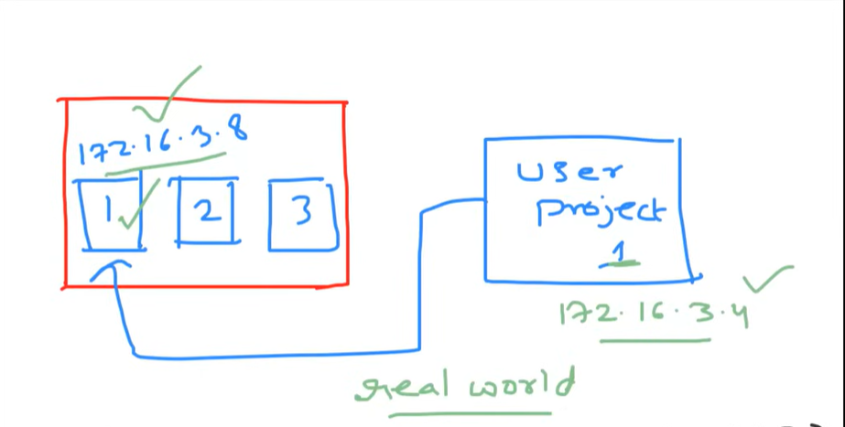

1. Load Balancing:

If a pod goes down, then automatically another pod is created but the IP address of the new pod gets changed.which the developers doesn’t know and be accessing the old Ip address.

So **SERVICE** is used to balance the load across the pods by using the url like ex. Payments.default.**svc.** Internally Service uses kubeproxy to give new IP address.

Service also acts as load balancer and distributes the loads across the ip addresses.

Service doesn’t rely on IP address so if any pod fails and with autohealing if another pod is created with different Ip address also, the load gets distributed properly.

Service Discovery:

Here we don’t care about IP address, but use Labels and Selectors where pods are given specific label name and if anytime pods go down then service looks for **SERVICE.**

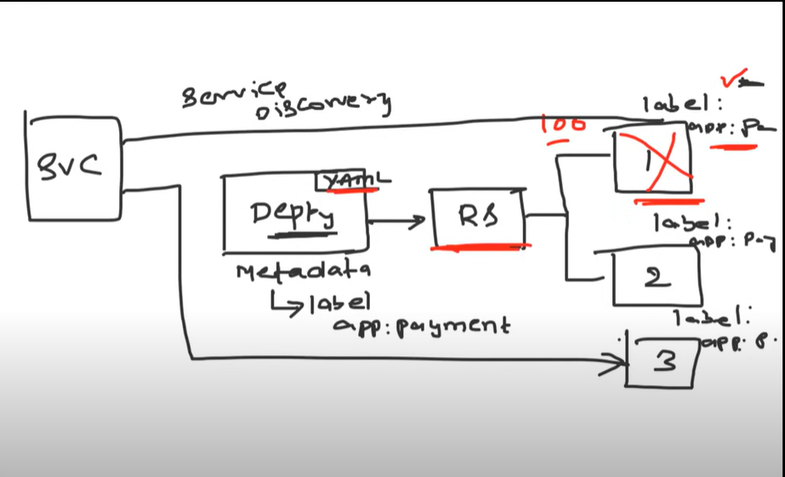

1. Expose to external world:

Services we can create in three types.

1.Cluster IP

1. Nodeport mode
2. Loadbalancer

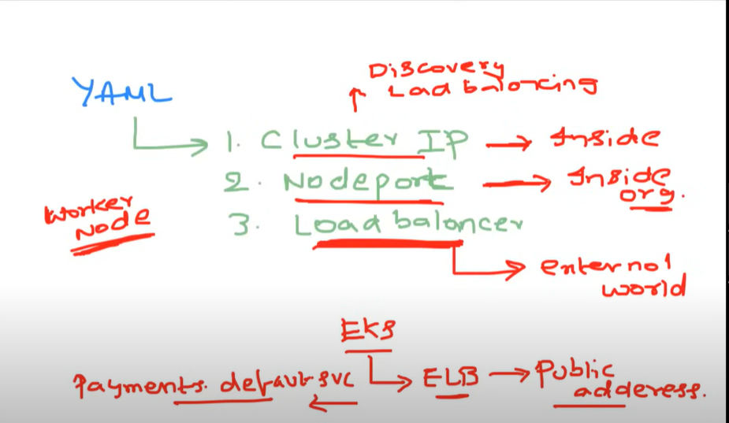

Cluster Ip - gives IP address access to only inside who have access to cluster

Node port - only inside organisation like worker , EC2, S3, VPC etc

Load balancer - On EKS--> ELB--->Public address with the help of CCM and anyone who has connection to Internet can have access

Interview Questions:

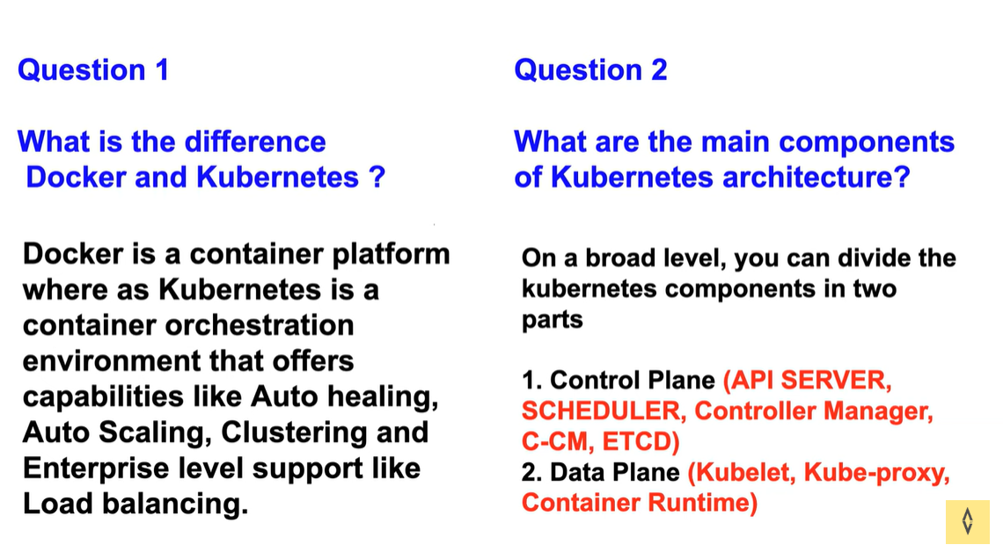

Kubernetes supports docker. But Kubernetes supports crio, docker shim etc and has the ability to switch in between.

Docker swarm is limited to small enterprises and may not be supported for large and heavy enterprises.

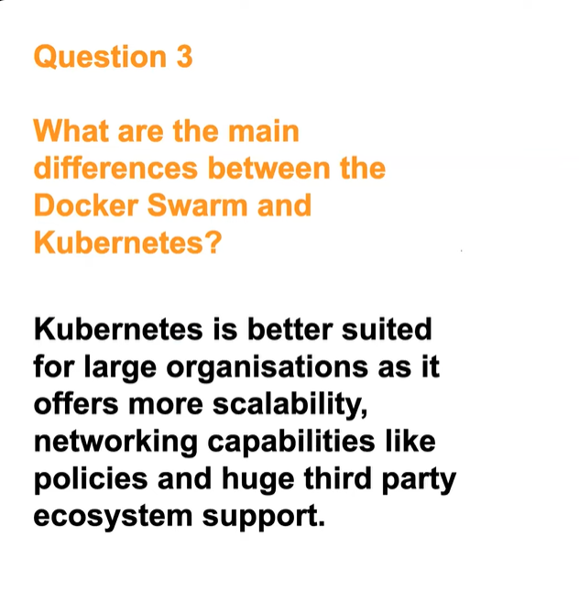

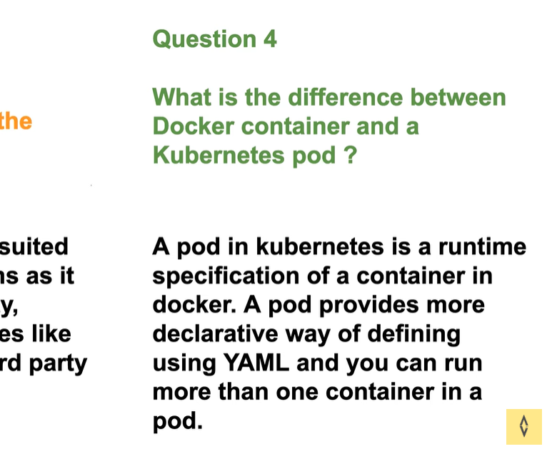

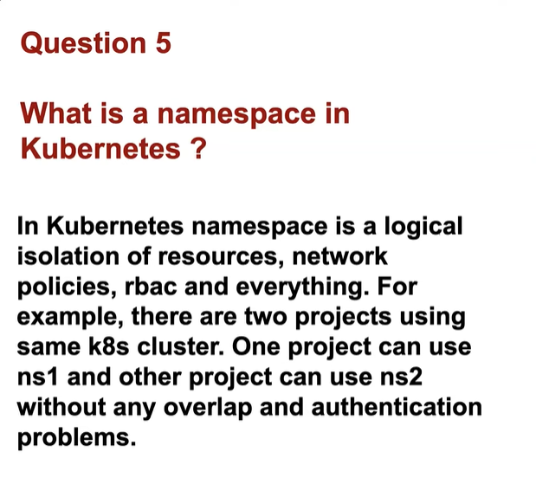

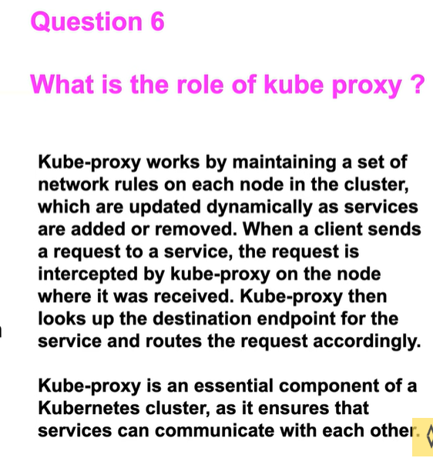

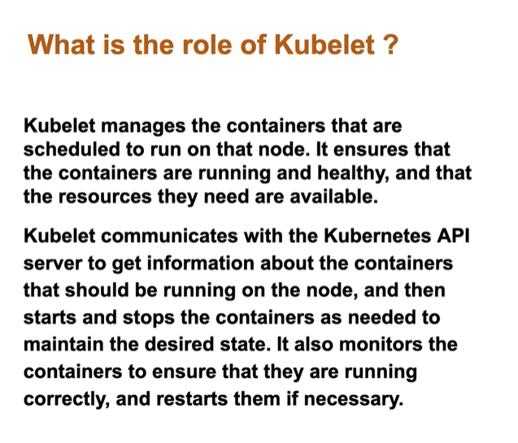



as part of the devops engineer role we manage kubernetes clusters for our organization and we also ensure that you know the applications are deployed onto the kubernetes cluster and there are no issues with the application so we have set up monitoring on our kubernetes cluster we ensure that whenever there are bugs on the kubernetes cluster for example uh the developers are not able to troubleshoot some issue with respect to pods developers are not able to troubleshoot with respect to Services they are not able to you know uh route

the traffic in inside the kubernetes cluster so in such cases as subject matter expertise on the kubernetes Clusters we coming to picture and we solve their problems but apart from that we also do a lot of Maintenance activities for example uh we have kubernetes clusters with three Master nodes and 10 worker nodes so we have to do some continuous maintenance activities on this worker nodes probably uh you know upgrading the versions of this worker nodes or installing some default mandatory packages ensuring that these worker nodes are not uh security uh exposed to security vulnerabilities so all of these things are our day-to-day activities on kubernetes apart from that we also serve as subject matter expertise on kubernetes so if anyone in the organization has any issues with kubernetes they create a jeera items for us or you know they create tickets for us and we will help them in solving or making them understand the concept of kubernetes

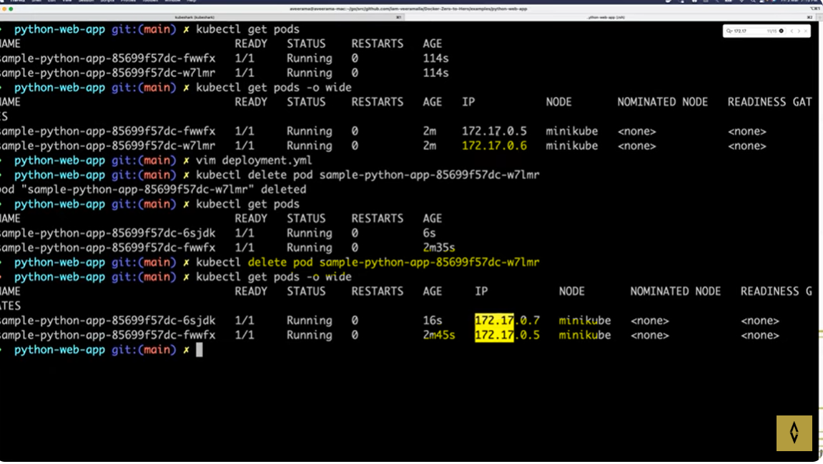

Here pod with ip address 172.17.0.6 is deleted. Then automatically another pod is created with ip address 172.17.0.5. This is dynamically allocatiion nature of kubernetes.

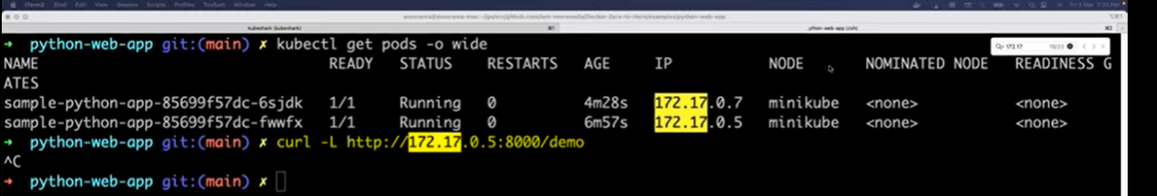

If we are trying to access application using curl command, then there is no traffic coming.

The below is the service.yml file. Now we have two things i.e. i)pod should be visible within the organisation(Nodeport) ii)pod should be visible to the outside world.(Loadbalancer)

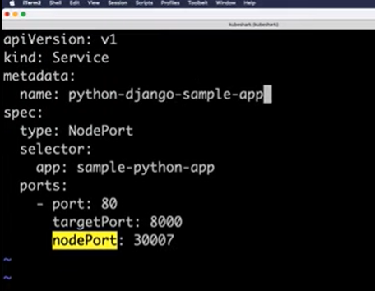

Here in spec section selector should be selected from template in deployment.yml file. Both should be same. Target port is the port on which our application is running.

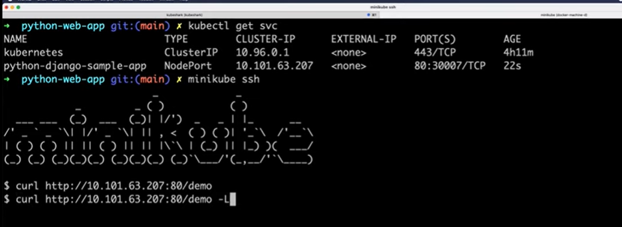

We can login using nodeport ip address to get the application. Same as like we do with pod ip address.

Also we can use node(minikube) ip address to access the application . The same http address can be used to access from the browser.

### **Summary**

* ****Minikube IP****: External IP for access from the host machine.
* ****Cluster IP****: Internal IP for communication among pods within the cluster.

The ****host machine**** refers to the physical or virtual computer that is running your virtualization environment. In the context of Minikube or Kubernetes:

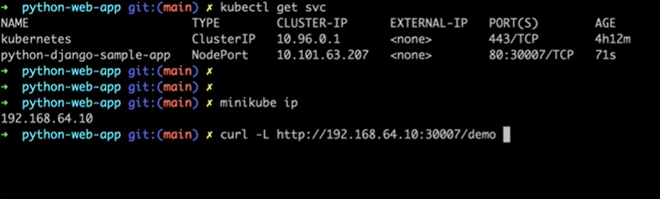

Loadbalancer:

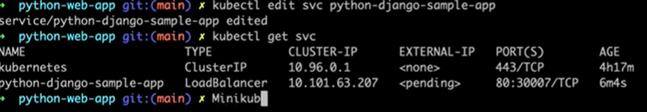

We can edit service.yml file or apply by changing type to Loadbalancer.

Here external ip is not allocated because it is minikube but in AWS or Azure it will be allocated by Cloud control manager(CCM)

Loadbalancing:

**Ingress:**

Kubernets at the start didn’t have enterprise level loadbalancing capabilities. So Ingress is introduced to have customized loadbalancing

1. Allocation of static IP adresses for loadbalancing and getting charged by the cloud providers.
2. Only simple round robin kind of loadbalancing

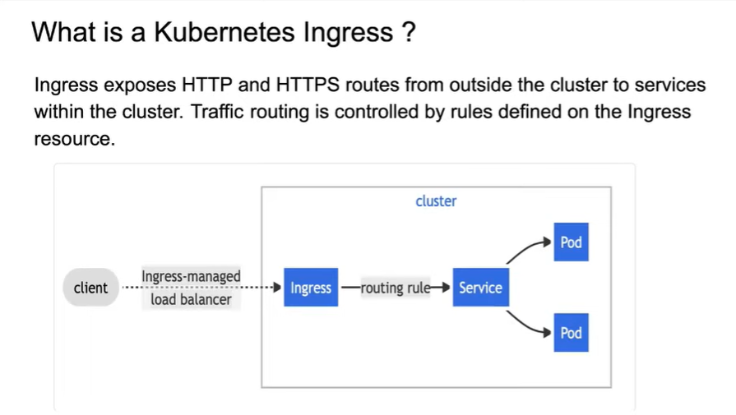

Before the introduction of Ingress in Kubernetes, several challenges were commonly faced regarding service exposure and traffic management within a Kubernetes cluster. Here are some of the key problems:

****Load Balancer Limitations****:

* 1. ****Cost****: Utilizing cloud provider load balancers for each service could become prohibitively expensive.
  2. ****Resource Inefficiency****: Each service requiring its own load balancer resulted in wasted resources and inefficient traffic distribution across applications.

****Service Discovery****:

* 1. Without a centralized way to manage routing, services within the Kubernetes cluster faced difficulty in discovering and communicating with each other effectively.

****Complexity in Routing****:

* 1. Setting up routes for HTTP/S traffic often required manual configurations for each service, leading to a complex and error-prone setup.

****SSL/TLS Termination****:

* 1. Managing SSL certificates and performing TLS termination was cumbersome and needed to be handled at the service level, increasing the configuration and maintenance overhead.

****Lack of Fine-Grained Traffic Control****:

* 1. There was limited ability to control traffic based on different rules or conditions, such as paths or hostnames, preventing smarter routing strategies.

****Monitoring and Logging Challenges****:

* 1. Observing and logging traffic patterns was more difficult due to the decentralized nature of service exposure, hindering insights into application performance and user interactions.

****Scalability Issues****:

* 1. As applications grew, scaling services up or down was harder without a unified mechanism to manage incoming traffic.

Ingress controllers were introduced to address these issues, providing a unified way to manage external access to services, improve routing capabilities, and simplify SSL management, among other benefits.

How Ingress is implemented?

First the users on kubernetes creates ingress resource on kubernetes cluster, later each loadbalancing companies create their own Ingress controller in github and will give steps to deploy them on cluster using helm or someother and and user have to deploy it on the cluster.

**Ingress.yml**

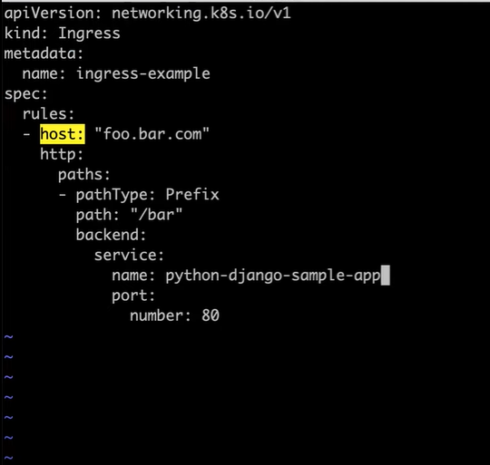

Host : the web adress like <http://foo.bar.com>

Path : specific page like <http://foo.bar.com/path>

Service: give the name of the service created

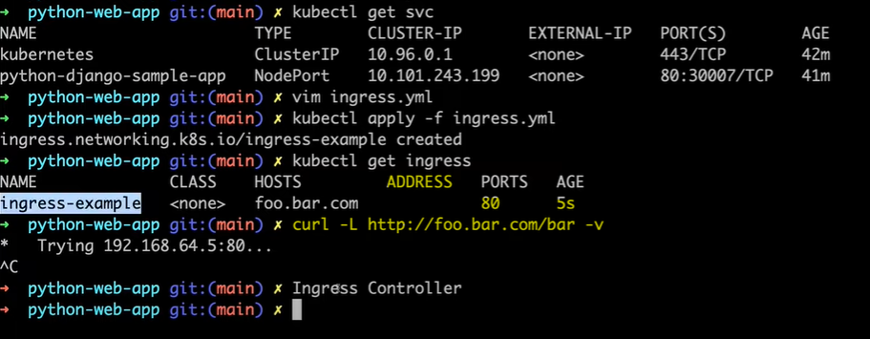

Here Address is empty because Ingress controller is missing.

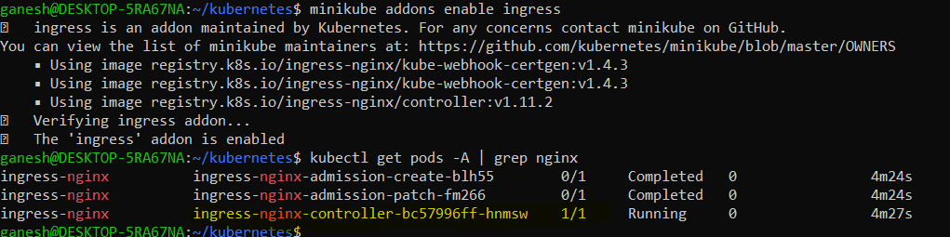

Ingress controller installed



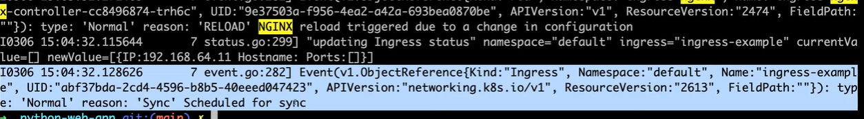

Now controller is able to detect Ingress.yml file

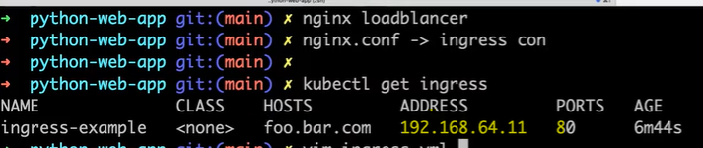

Now address is displayed

We have to map domain name to IP address in etc/hosts file. Not reqired in production environment.

**Kubernetes RBAC:(Role based access control)**

RBAC is divided into two types

**Users**

Who are the people that should have access to for the kubernetes cluster will be defined

**Service Accounts (access to services)**

If a pod is created should it have access to configmap, secrets etc

How to define RBAC in kubernetes?

1. Service Accounts/Users
2. Roles/Cluster Roles
3. Role Binding/cluster role binding

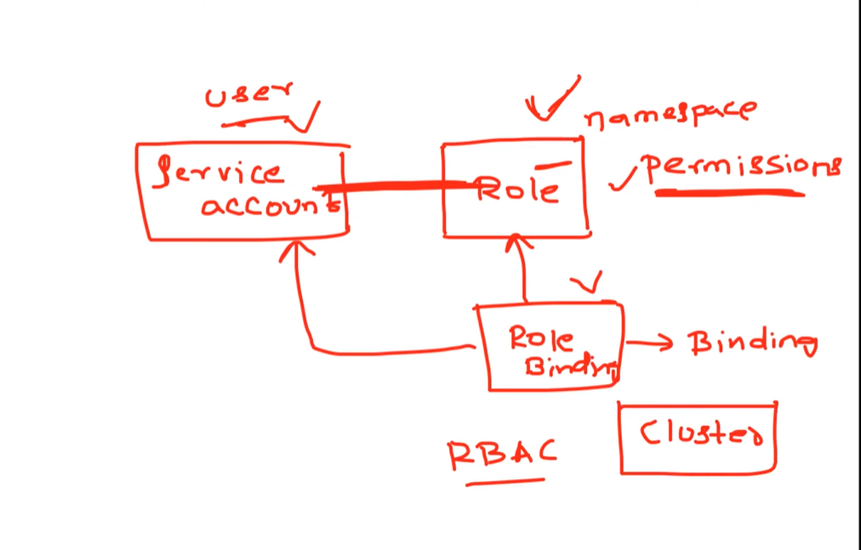

We will ceate Service account or user first and Role then they both are combined using Role binding. If it is done using a cluster then it is called cluster role binding

**Custom resources:**

If we want to create a new resource then we have to extend API in kubernetes then we use Custom Resource

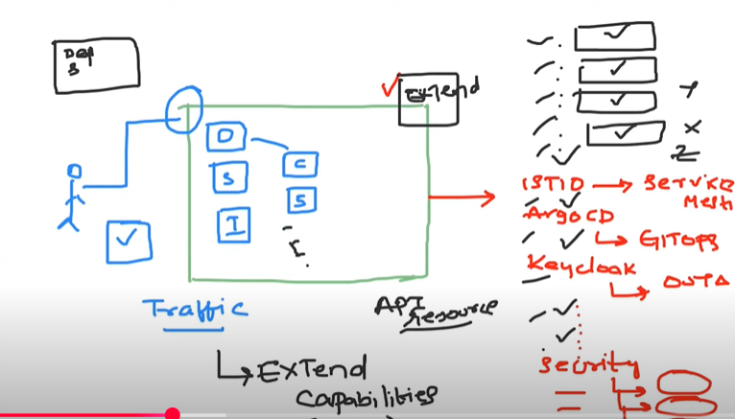

To extend we use

1. CRD- custom resource definition
2. CR- custom resource
3. Custom controller-

**The custom API is wriiten by the company to kuberentes in CRD and user submits that in CR**

First CRD is deployed on to the cluster using manifests/Helmcharts/Operators. Using docs provided by the company. Let us name it **virtualservice**

Next Devops engineer creates a Custom resource(CR) and validates the CRD against it.

Now Custom controller has to be deployed using the docs.

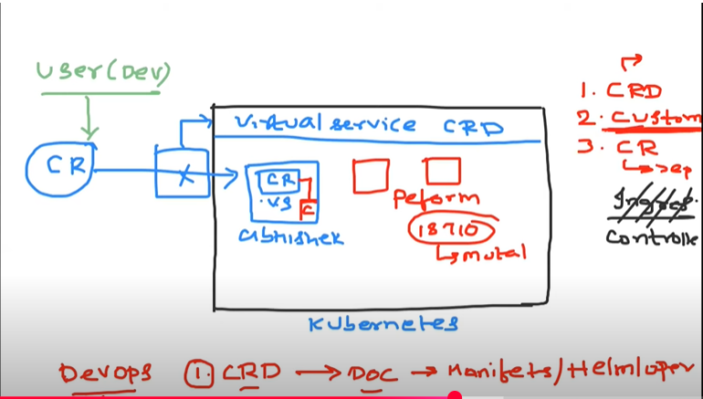

Config Maps:

ConfigMaps store data that cluster uses at later point of time like ENV variablesor ENV file.

Secrets are also doing the same job but deals with sensitive data.

The info which is stored in config maps also get stored in ETCD whenever a resource is created compromising security. So sensitive data is stored in Secrets

If data is stored in secrets then before getting stored in etcd data is encrypted.

For Secrets strong **RBAC** is recommended.

Also **Least Privilege** concept is followed where least number of people gets access.

Cm.yml file:

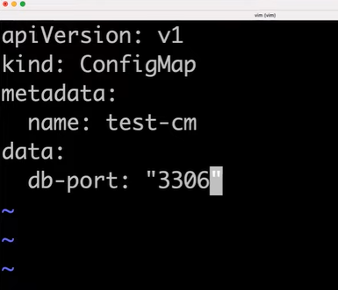

Here we declared db-port

If we want to use the db port as ENV variable then we have to modify deployment.yml file as below

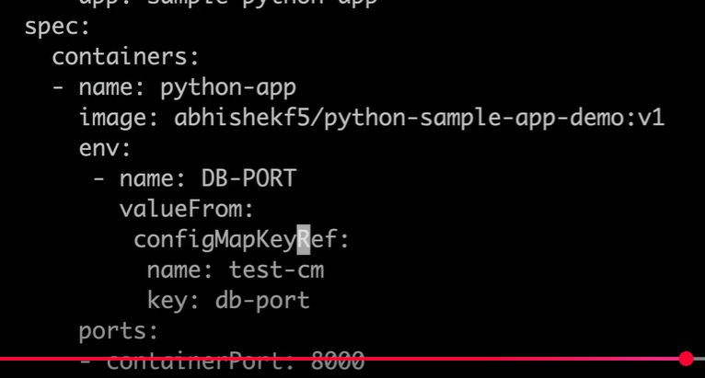

Now check if the env variables are visible. Login to the pod in interactive terminal mode (it) and look for env variables.

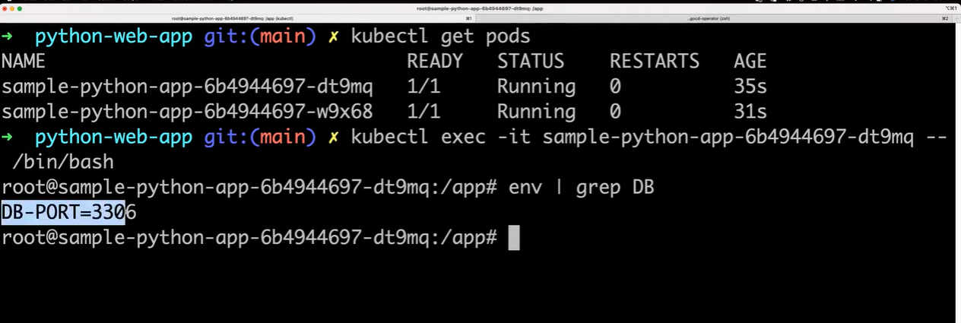

If we want to change the ENV variables that will not be possible with configMaps.Once created we cannot change.

In this case we can use VOLUMEMOUNTS

First create the volume then mount it

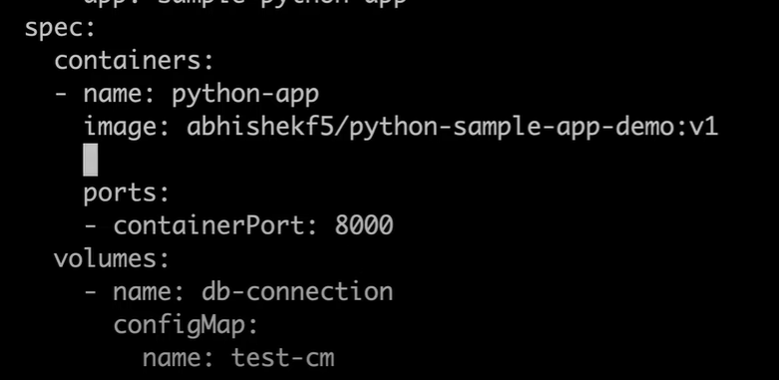

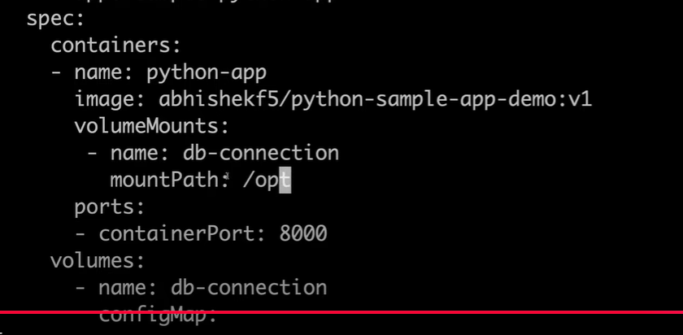

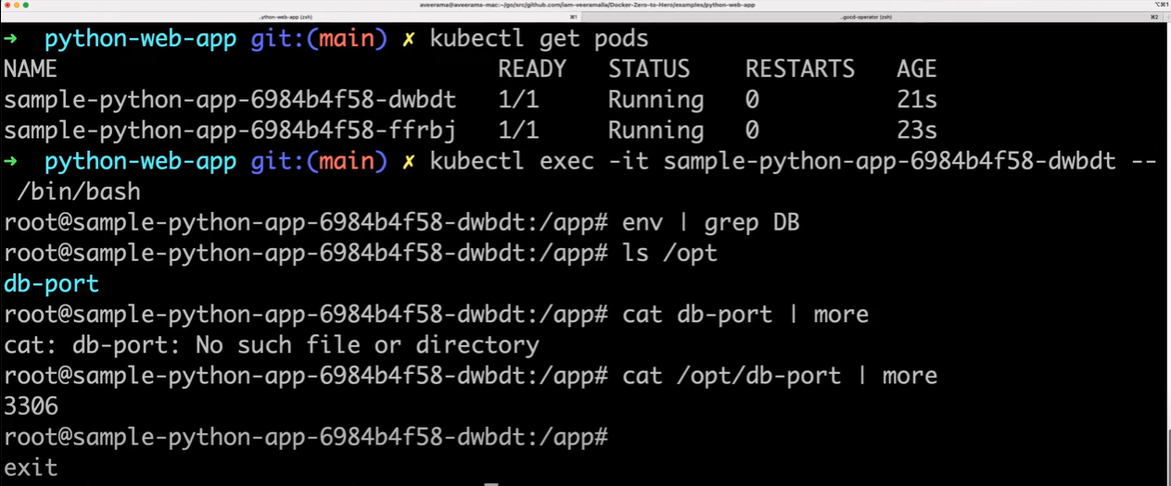

Now try changing dbport in cm.yml to 3307 and apply.

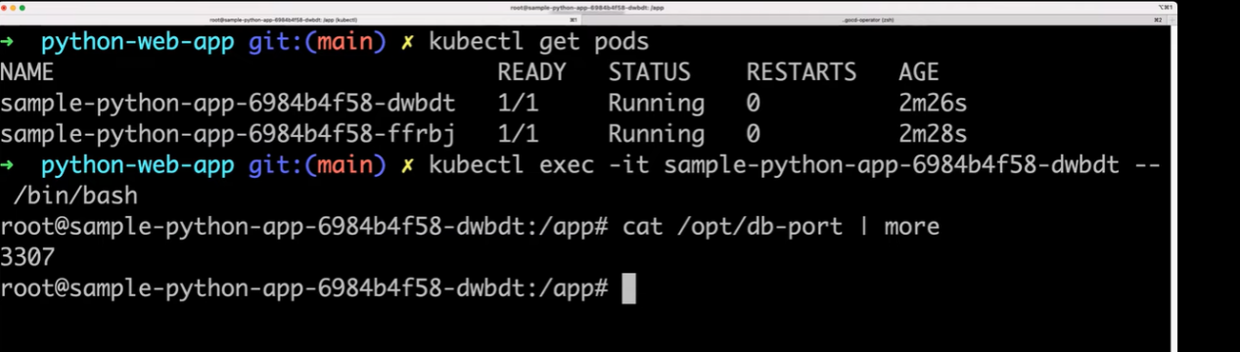

The pod doesn’t get created new but dbport gets updated

SECRETS

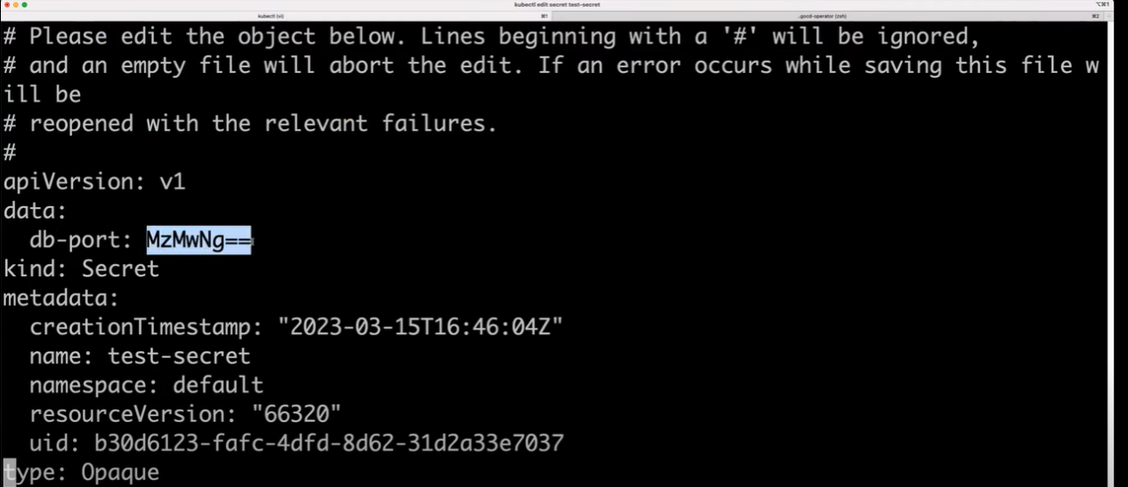

Port value is encrypted.

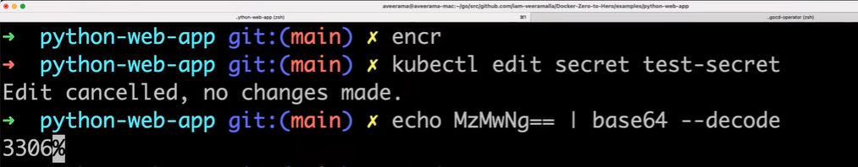

RealTime Challenges with Kubernetes:

1. Resource Sharing- How to allocate cluster space for different environments?

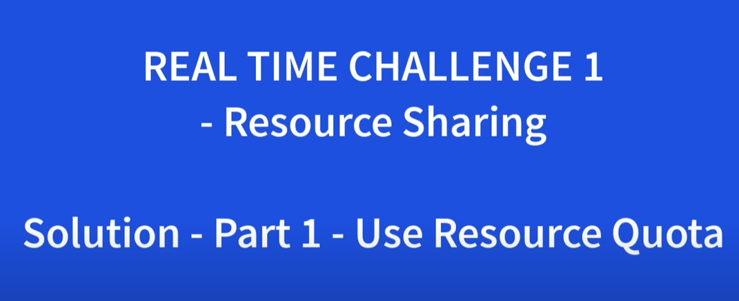

Error faced: OOMKilled(OutofMemoryKilled)

Sol: ResourceQuota

We put a limit on the resources for a namespace by performing performance benchmarking

1. What if a service in a namespace is leaking memory?

Resource Limits- limit applied onto pods on a particular namespace

2.



Error- OOMKilled Status- CrashLoopBackoff

Collect Threaddump by using kill -3 command

Collect Heapdump by using jstack command and share them with development team and will come up with new version of application and as a devops engineer we have to deploy on to the pod again



Created a manual steps notes which includes

1. Take backup
2. How to read Release notes
3. Control plane and Data plane - How to start with ETCD, API Server, Scheduler and how to schedule updates.

First drain the node means to move pods from one node to another node then unschedule it means no services are running on it. Then upgrade the kubelet version and install required packages

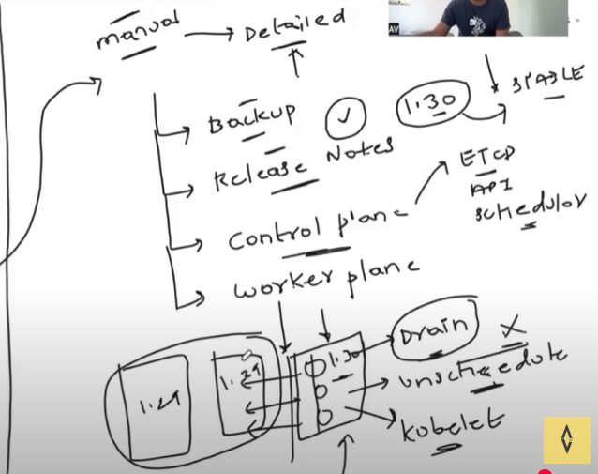

Deployment Strategies in Kubernetes:

Why deployment strategies are required?

To reduce downtime while upgrade aiming almost zero and negligible negative user experience

**Rolling Update**- comes with kubernetes default with near zero downtime

Let us ay there are four copies of version 1 that need to be upgraded to version 2. First 25% of the replicas are upgraded without uninstalling ie out of four one gets new version.

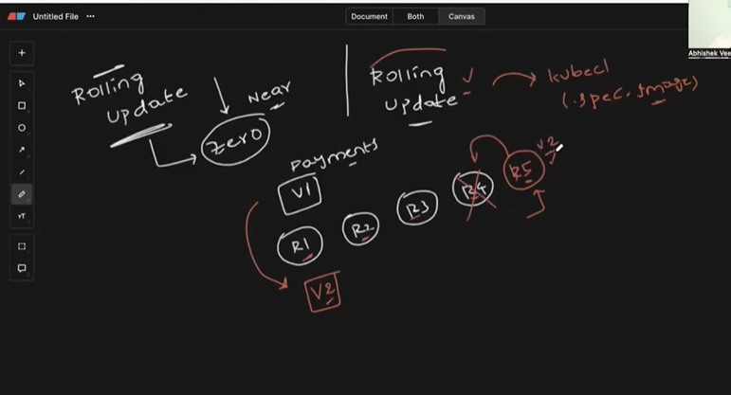

It will create R5 and replace one among the four with R5 which is V2. If everything goes well then R6 R7 R8 will be replaced with the older version ones.

If this upgrade doesn’t go well then the rest three will handle traffic without impacting the application.

How to do this?

Strategy:

Maxunavailable-25% tells us how many replicas to be upgraded at once

Maxsurge-25% tells us how many new replicas has to be created at once

How does Kubernetes understand if the new replica is ready to accept the traffic?

We should first configure **ReadinessProbe**

**Canary deployment:**

Why Canary deployment is required?

We may test the application with data in lower stages like preprod but doesn’t work in prod.

In canary deployment we deploy

the new version of appliaction on to the production and allow access only to a certain set of audience by telling the loadbalancer to give traffic like 10 % to new version and 90 % to the old version.

**Blue-Green deployment:**

**Safe and costly**

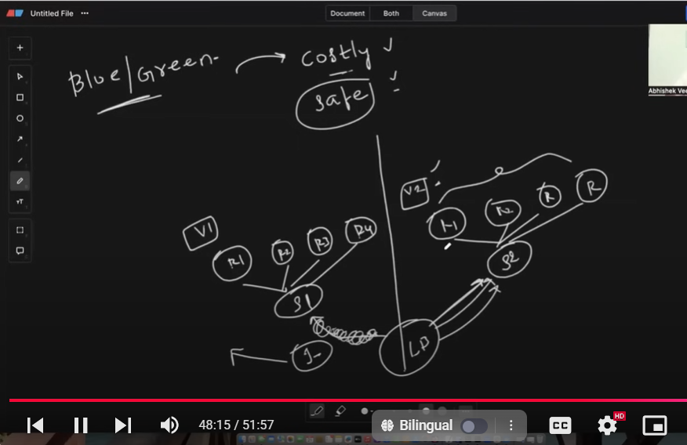

In ingress.yml just point the loadbalancer from service 1 to service 2. If nything goes wrong then simply point back to service1.

**How to upgrade clusters in kubernetes in Prod with zero downtime?**

In general kubernetes cluster supports only the three previous versions only.

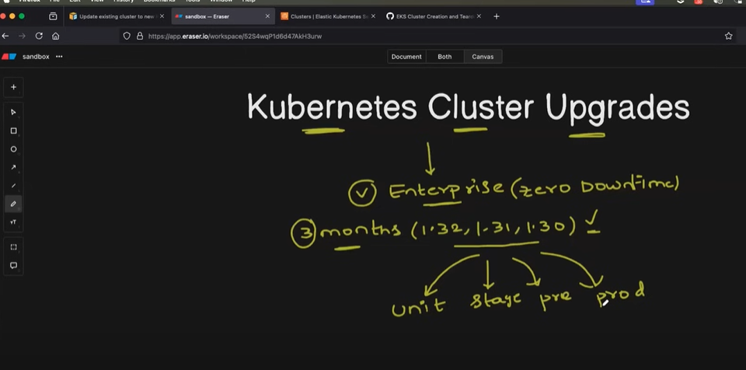

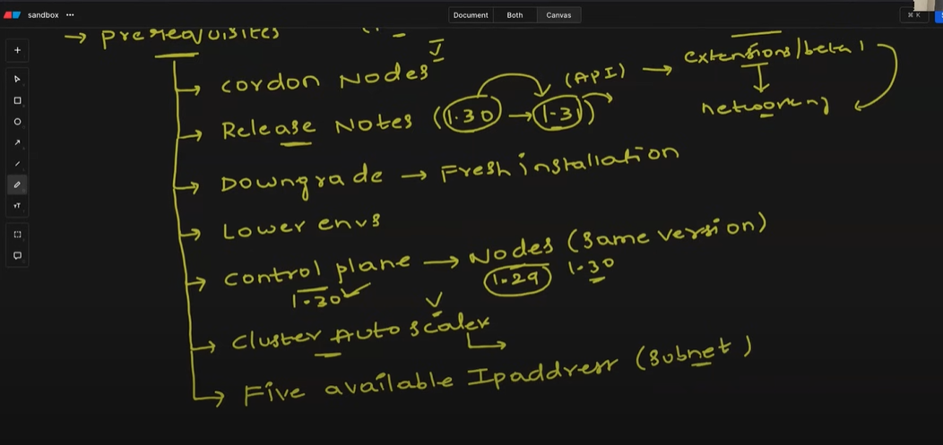

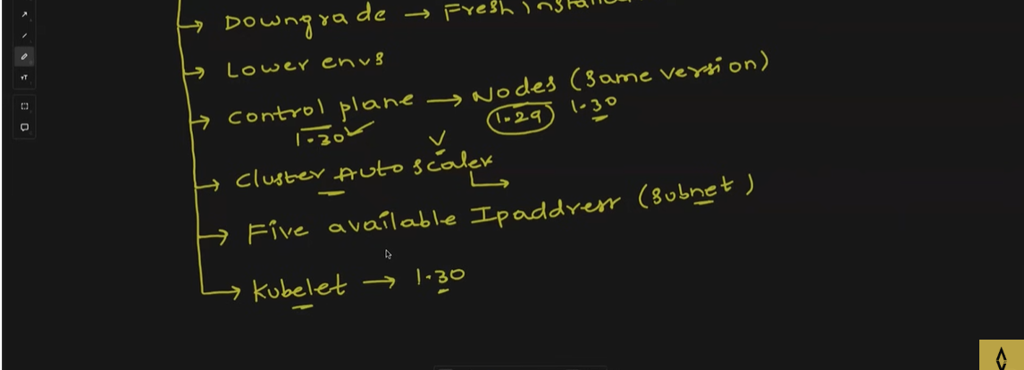

1. **unschedule all the nodes**
2. **Read proper release notes before upgrading**
3. **Downgrading is not possible and might require a fresh installation if not done properly**
4. **First properly check in lower environments**
5. **Controlplane and the nodes should be of same version**
6. **Cluster auto scaler must be same of controlplane version**
7. **There should be 5 ip addresses available during creation of subnet.**
8. **Kubelet should also match the version of the control plane**

**What is managed kubernetes cluster?**

**If the below three steps are implemented then cluster upgrade can be considered as complete**

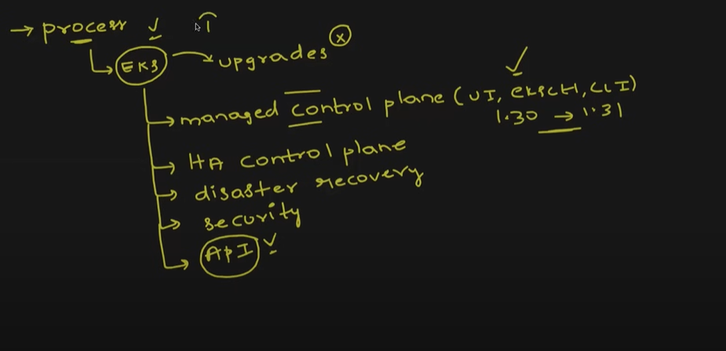



Key features of them but the upgrades are not automatic and should be done using UI or EKSCLI or CLI

AWS EKS:

Why EKS?

EKS is a managed kubernetes services where managed **controlled plane** is available with robust, highly available system and does not prone to issues like API server failure, etcd failure, certificate expire issue, scheduler crash etc because they are auto managed by aws.

We can create ec2 instances for dataplanes and attach them to the control plane but we have to manage all the issues which is not preferable.

**So Fargate which is aws serverless compute**  is used to create **data plane nodes** and attach to control plane and all the services are available within it and no external management is required.

In this way a complete managed kubernetes system is available

Now if we want to access an application present in vpc which is in private subnet may not be possible and we have to use loadbalance mode ip address which might get very costly.

So we move to ingress resource.

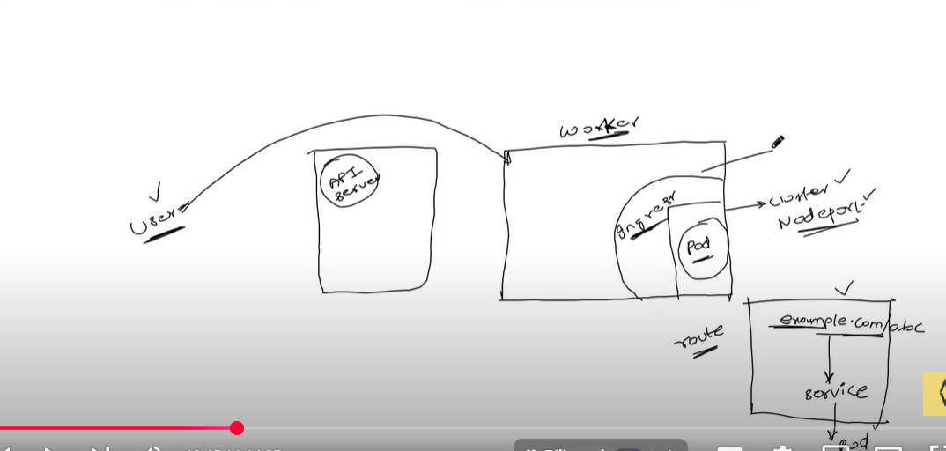

In ingress.yml file if anyone wants to access application on example.com/abc then request is forwarded to service and from there it goes to pod.

Here the user can access application on public subnet but not on private subnet. We can place loadbalancer on public subnet and ingress controller on private subnet and we can access through service and then pod.

EKS project:

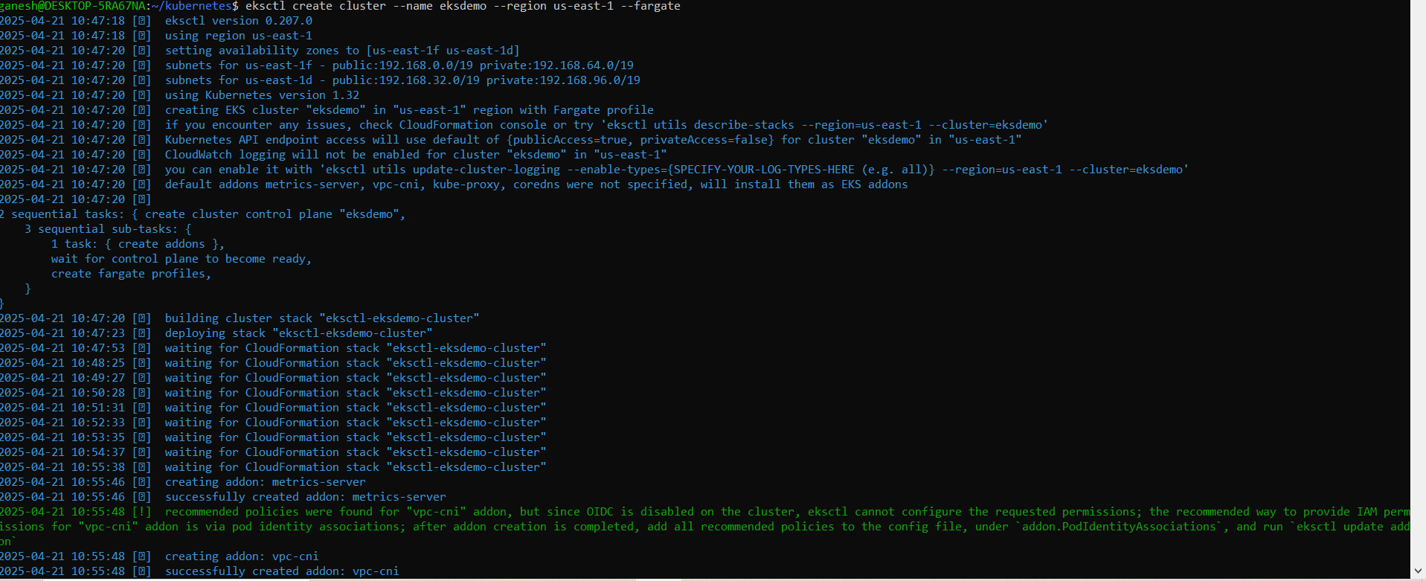

We can use the below command to connect to awseks through commandline

aws eks update-kubeconfig --name eksdemo --region us-east-1

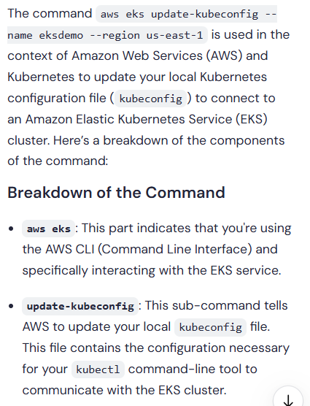



Create a separate namespace for fargate and we will deploy the app in this namespace

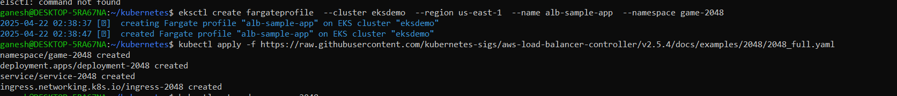

Though ingress.yml is present IP address is not created

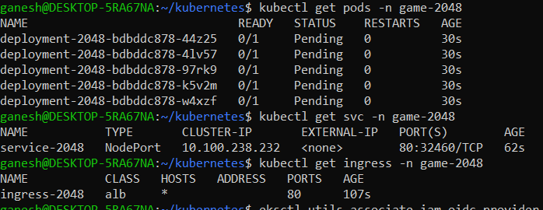

For creating Ingress loadbalancer first we have to authenticate OIDC



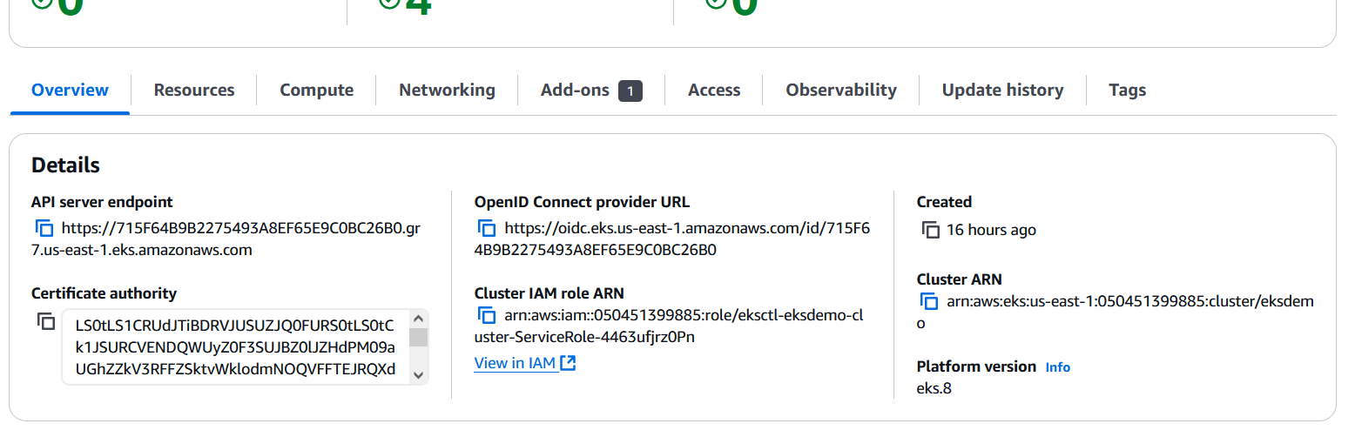

OpenID is used to connect with Identity provider like LDAP, keyclock etc

Create IAM policies for the loadbalancer.

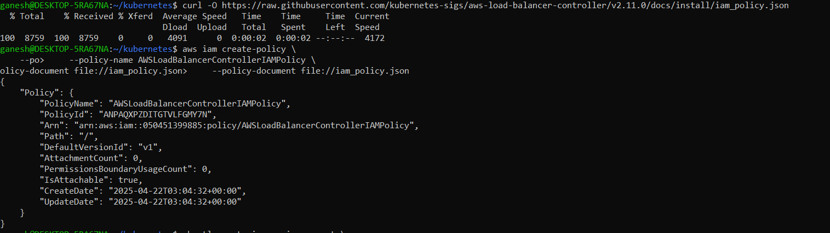

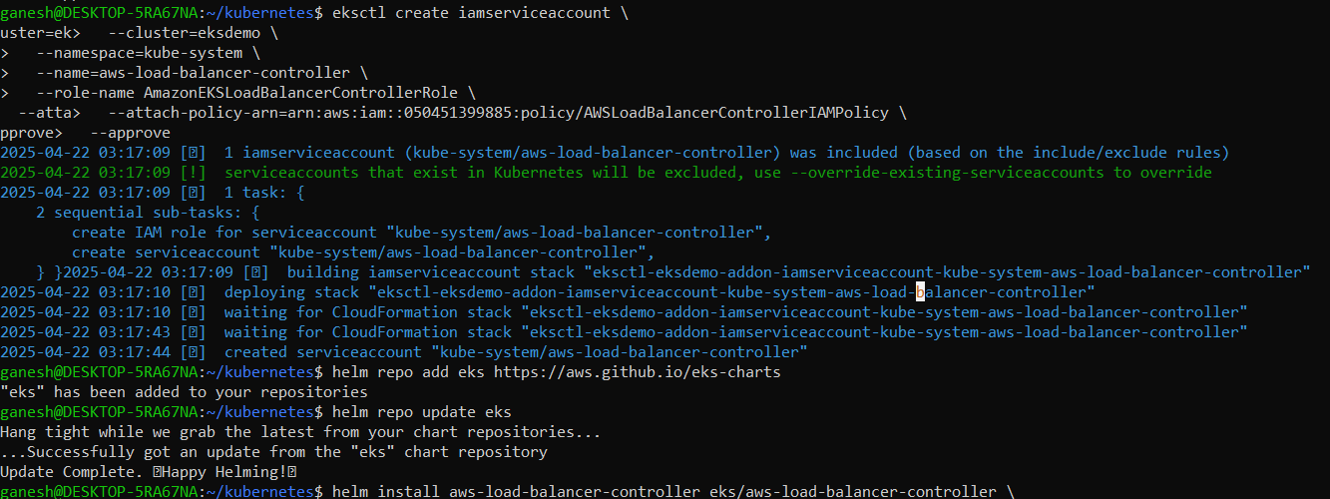

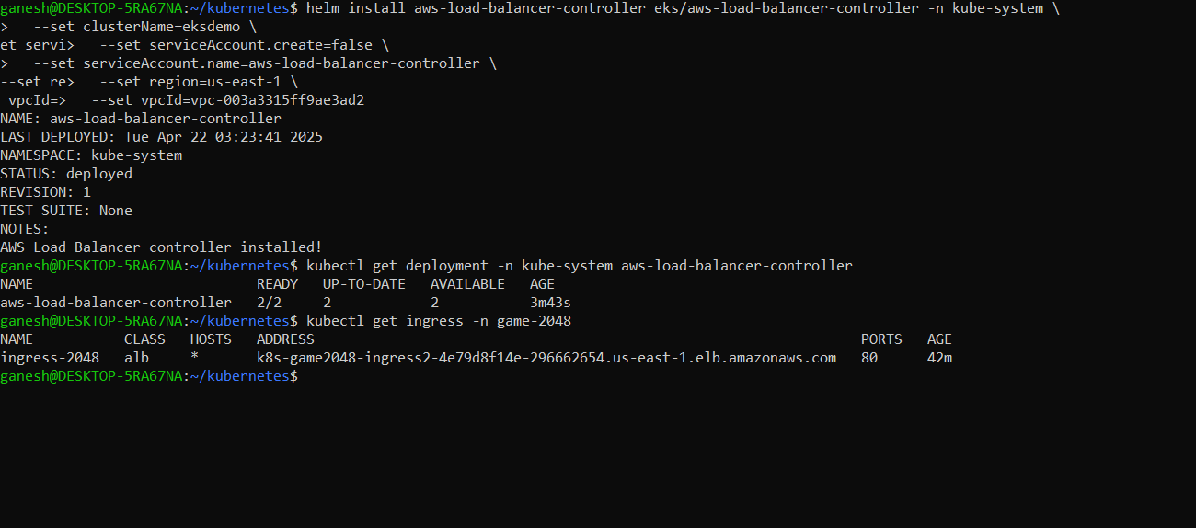

Finally we can get the ip address.